Computer Language Coding Concepts

Related Item in a Diagram
The concept of related item is explained in the article Related Item. The current article demonstrates it in a diagram.

A relation to another object is part of the parent object. A parent object is a real object. Its related item is not a real object, but a pointer to an object. The system interface of a related item determines which object the parent will refer to.

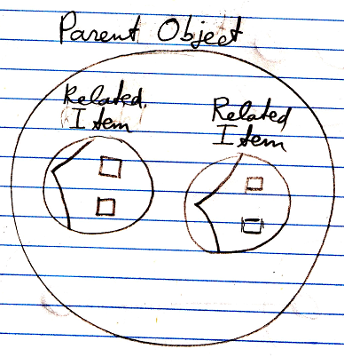

The pointers, so the system objects, are part of the parent object.

The complete interface of the related item system object looks like this in a diagram:

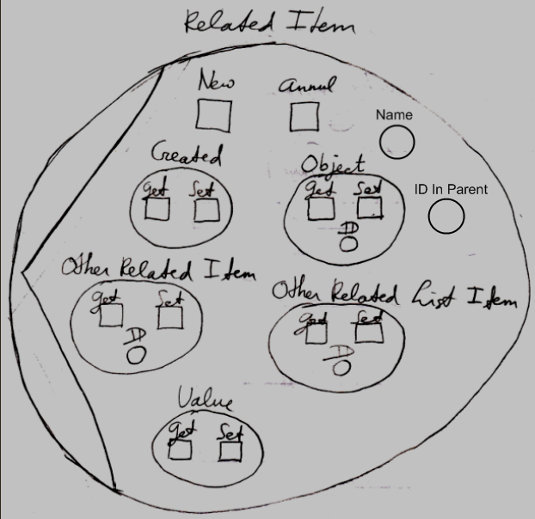

The members of the related item system object will be covered in the separate articles:

- Names of Related Items & Related Lists
- Related Items & Related Lists Collections
- New & Annul
- Object Get & Set
- Pointer To Pointer Get & Set
- Value Get & Set

The article Related Item mentions pointing not to a specific object, but to another →1 related item or →n related list item. That concept will be demonstrated with diagrams in the article Pointer to Pointer in a Diagram.

Decorating assignment and retrieval of a related item with extra procedures will be covered by the article Extending the System Interface.

See also: System Objects, Related Item, New & Annul, Names of Related Items & Related Lists, Object Get & Set, Pointer To Pointer Get & Set, Value Get & Set, Pointer to Pointer in a Diagram, Extending the System Interface

Author & Copyright: Jan-Joost van Zon Date: July 18, 2008 – July 24, 2008 Location: Oosterhout, The Netherlands Status: Finished

